AI-BASED SMART TRAFFIC MANAGEMENT
Scope and Limitations
Department of Computer Science and Engineering, TKR College of Engineering & Technology
Batch A10 (CSE-A) · Academic year [ACADEMIC YEAR]
Table 1: Project team
S.No. | Student name | Roll number
1 | Buneti Harshitha | 23K91A0548
2 | Bhuvaneshwari Kadike | 23K91A0537
3 | Ambati Sai Nikhil Reddy | 23K91A0510
4 | Chapala Rohith Reddy | 23K91A0551

Project guide: Laxmi Prasanna
Chapter and section numbers quoted in the text (for example Chapter 8 or Section 6.2) refer to the full project report, 17.Final Document. Figures and tables in this document are numbered from 1.

1. SCOPE

1.1 In scope
• Signal control in a simulated grid of 2x2 or 3x3 two-phase junctions with four approaches each, four controllers, a demand multiplier from 0.4 to 2.0 and a time-of-day profile with morning and evening peaks.
• Vehicle detection and density estimation on camera frames: YOLOv8n on photographs and uploads, a contour detector on rendered overhead scenes, passenger-car-equivalent density and a recommended green time.
• Emergency-vehicle handling: a red-plus-blue light-bar rule on detected vehicles in the vision layer, and pre-emption with an upstream green wave in the simulator.
• Congestion forecasting: queue 30 s ahead per approach from simulated junction data.
• Inter-junction coordination as look-ahead on vehicles in transit between junctions and spill-back avoidance.
• A violation log for red-light jumping and wrong-way driving with plate, vehicle class and confidence.
• The console and API: sign-in with a demo operator account, live control, benchmark, vision, prediction and violations screens, 20 HTTP endpoints, tests and a launcher.

1.2 Out of scope
• Real camera streams (RTSP), video decoding, multi-object tracking and number-plate recognition.
• Training a light-bar or emergency-vehicle detector, or fine-tuning YOLO on local traffic.
• SUMO, CARLA or other microscopic simulators, and calibration of the simulator against field counts.
• Hardware: signal controllers, controller-area networks, V2I radios, edge devices.
• Pedestrian phases, turning-lane phases, left-turn protection, bus priority and signal plans with more than two phases.
• Persistent storage, user management with roles, multi-tenant operation and cloud deployment.
• Safety evaluation (conflicts, collisions) and any legal or regulatory assessment of automatic enforcement.

1.3 Boundaries of the product
Table 2: Dimensions of the delivered system
Dimension | Delivered
Network sizes | 2x2 (4 junctions) and 3x3 (9 junctions), two-phase signals, 12 s links
Controllers | Fixed-time, queue-actuated adaptive, emergency-aware (base-paper style), advanced
Vehicle classes | Car, bike, bus, truck, ambulance (PCU 1, 0.5, 3, 2, 1)
Vision modes | Synthetic scene, YOLOv8n on the sample photo, YOLOv8n on an uploaded image (up to 12 MB)
Forecast | Queue per approach, 30 s ahead, gradient boosting, trained at API start-up in about 6 s
Interface | React console (8 pages), FastAPI backend, demo login, light and dark themes
Hardware used | Intel Core i5-12500, 15.7 GB RAM, no GPU

2. ASSUMPTIONS
The results depend on the following assumptions, all of which are choices of the project rather than findings.
• Traffic model. Arrivals are Poisson at the entry roads with base rates of 0.15 veh/s on the north and south entries and 0.10 veh/s on the east and west entries, scaled by the demand slider and a rush-hour profile peaking at 08:30 and 17:30; the vehicle mix is 68 % cars, 13 % bikes, 6 % buses and 13 % trucks.
• Discharge and timing. Saturation discharge is 0.5 vehicles per second per approach, with 2 s of start-up lost time and 3 s of yellow and all-red clearance; a link takes 12 s; an approach holds 30 vehicles before spill-back blocks upstream release.
• Signals. Each junction has two phases (north-south and east-west) and no turn-specific phases; vehicles turn right or left with fixed probabilities and leave the network at its edge.
• Emergency vehicles. Ambulances are known to the simulated controllers by ground truth within a look-ahead (5 s for the base-paper style, 15 s for the advanced controller); the vision layer is evaluated separately.
• Violations. 5 % of cars are red-light runners that pass after 25 s on red, and a wrong-way driver appears with probability 0.0003 per entry second.
• Fuel and CO2. An idling vehicle burns 0.6 L/h and 1 L of fuel gives 2.31 kg CO2.
• Evaluation. Five seeds (three for the demand sweep) at demand x1.2, 1800 s, start 08:00 unless stated; the predictor is trained on six simulated runs under the adaptive controller.
• Operation. One demo operator, one shared live simulation, the API and the console on one machine.

3. LIMITATIONS
The limitations below are properties of the delivered system and of the evidence, ordered by how much they affect the conclusions.
Table 3: Limitations of FlowSense and their effect
Limitation | Evidence | Effect on the conclusions
No trained emergency detector | Light-bar rule recalls 4 of 300 real ambulance photos (0.013); 100 % on synthetic scenes | The camera-to-signal link for ambulances is demonstrated only in simulation with ground-truth knowledge
Stock COCO detector on mixed traffic | Real frames: 4-wheeler recall 0.586, 2-wheeler 0.083, 3-wheeler 0.000 | Density estimates would undercount two- and three-wheelers; objective 1 only partly met
Brittle classical detector | No detections under Gaussian noise sigma 10; light bar lost at brightness x0.6 | Synthetic-scene success is not evidence of robustness
Simulator, not SUMO | Parameters are the authors' assumptions; no calibration with field data | Absolute delays are not comparable with the base paper or with real roads
Small gain over plain adaptive control | -4.3 % (2x2), within one standard deviation; worse at demand x0.6 and x0.9 | Most of the improvement over fixed-time comes from adaptivity itself
Forecaster outside its range | Leave-one-run-out R2 0.04; MAE 14.66 against 5.49 on the congested run | The random-split R2 of 0.96 overstates real performance; closed-loop benefit about 3 s
Pre-emption has a cost | Base-paper style is 6.5 % (2x2) and 2.2 % (3x3) slower than adaptive; no pre-emption gives ambulance delay 27.3 s | A deployment must choose the trade-off explicitly
Violations are simulated | Events come from ground-truth runners; confidence is a random draw in 0.86-0.99 | The Violations screen demonstrates logging, not detection
No persistence, one operator | State lives in the API process; demo login only | Not a multi-user or production system
Small statistical base | Five seeds, standard deviations 2.8-11.0 s on the 2x2 grid | Differences below one standard deviation are not established

Two figures show the limitations that matter most for reading the numbers. The first compares how the 30-second queue forecaster scores on a random split with how it scores on a whole simulation run it has never seen: the random split overstates what the model can do. The second shows the vision layer's robustness on synthetic scenes: the classical detector and light-bar rule work on clean synthetic frames and fail under mild noise, darkness or blur, and the real-photo results are far weaker still.
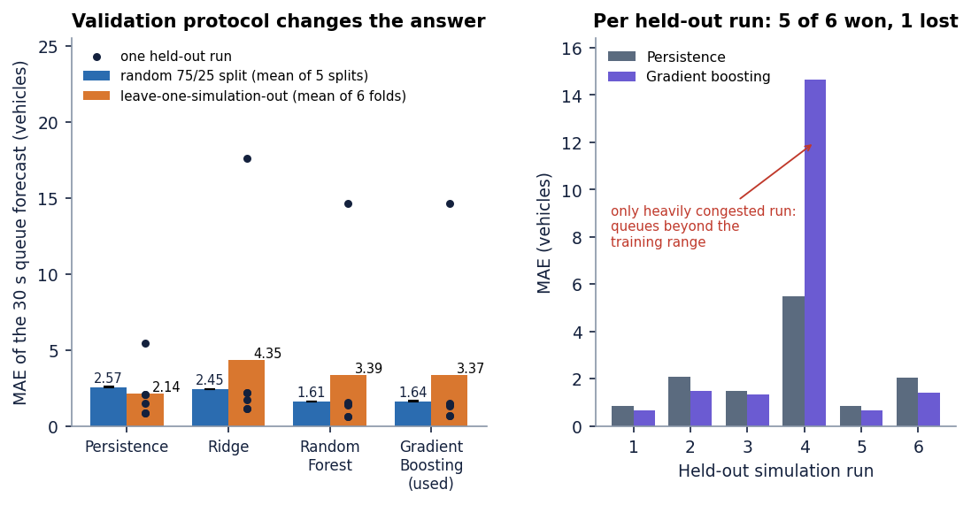
Figure 1: Queue forecaster error on a random split and on held-out whole simulation runs (leave-one-simulation-out), with the persistence baseline.
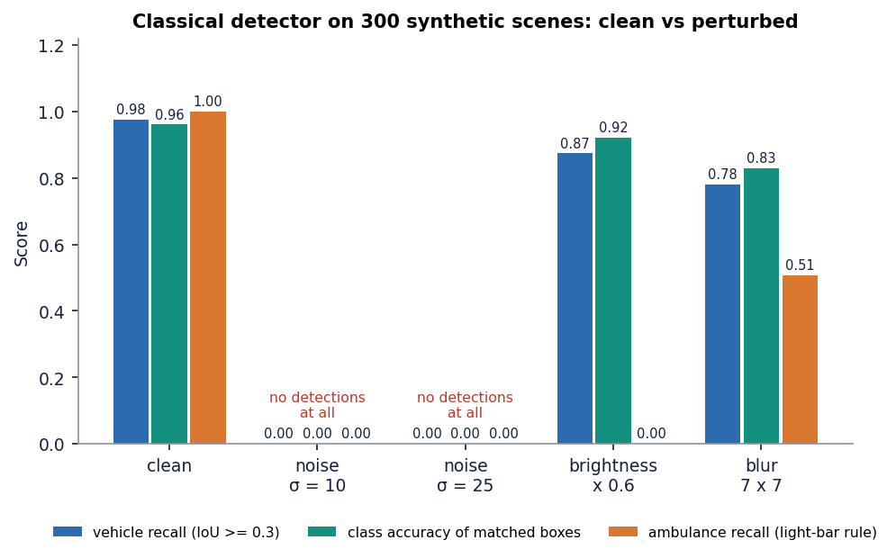
Figure 2: Recall and ambulance recall of the synthetic-scene detector under noise, darkness and blur.

4. WHAT WAS NOT MEASURED
The following were not measured, and nothing in the documents should be read as a result for them:
• Detection accuracy of a trained light-bar or emergency-vehicle model, and any temporal-confirmation logic (the base paper's three-frame rule).
• Violation-detection accuracy: there is no detector and no labelled violation data.
• Behaviour with a live camera stream, tracking, night-time, rain or glare conditions.
• Accuracy of the simulator against field counts, and any comparison with SUMO or CARLA.
• Safety outcomes such as conflicts or collisions, and effects on pedestrians or cyclists.
• Performance with many simultaneous users, long-running stability, and failure behaviour of the API.
• Security of the demo authentication (no penetration test); the signing key is a development default unless .env supplies one.
• Energy use and hardware cost of an edge deployment; the base paper's 11-14 ms detector latency was measured on a GPU and ours (about 32-51 ms) on a CPU, so they are not comparable.

